

Exploring

the Way







Glory be to the Father –

in whom we live and move

and have our being.

Glory be to the Son –

whose name we bear

and who calls each of us

to be his disciples;

to build his Kingdom

and to go out into the world

and bear its fruit.

Glory be to the Holy Spirit –

pouring out grace and guidance,

forming us and renewing us.

Inspire us all

in the Diocese of Hexham and Newcastle

to live the Gospel,

to be open to change

and to move forward together in hope.

**Foreword**

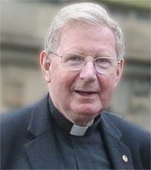The purpose of *Forward Together in Hope*is to help us discover how to be more committed disciples of Jesus Christ. It will also help us find a way of making best use of our resources in order to ensure we have a thriving and sustainable Catholic community into the future.

Earlier this year all parishes and schools in our Diocese were provided with resources to enable them to understand more about *Forward Together in Hope* and to start to prepare for the journey ahead. It is really encouraging to see the various ways in which worshipping communities are embracing and responding to the invitation to take part in this journey of renewal. Many are praying the *Forward Together in Hope* prayer every day and have used the introductory DVD during Sunday masses. Others have undertaken 24 hour prayer vigils, poetry competitions and a wide range of other initiatives aimed at communicating the message and ensuring that the whole process is firmly rooted in prayer.

As we move into the next stage – *Exploring the Way* – it is even more important that as many people as possible are directly involved in the consultation and reflection taking place across the whole of the Diocese.

Between now and the beginning of Advent, I urge every community to engage fully with the self-evaluation process and complete the accompanying questionnaire prayerfully, carefully and honestly. I am sure it will help each community discover more about itself and start to consider how it can best flourish into the future.

The period ahead will not be without its challenges and obstacles but I believe that the Holy Spirit is with us all, inspiring us and guiding us as we continue to move forward together in hope.



+ Séamus Cunningham

Bishop of Hexham and Newcastle

**Forward Together in Hope - Stages of the Journey**

**PREPARING THE WAY**

* Developing liturgies and prayer resources
* Developing and distributing information leaflets and guidance
* Informing everyone about the approach through meetings, documents and a DVD
* Initial meetings and training for clergy and laity
* Bishop Séamus leads days of reflection

**Autumn 2014 - Spring 2015**



**EXPLORING THE WAY**

* Prayer and liturgies across the Diocese
* Providing unique data to each parish
* Extensive consultation and self-evaluation

process in each worshipping community

* Support and advice from the Diocese
* Return of completed self-evaluation questionnaire and recommendations
* Detailed analysis and validation of responses
* Clarification meetings and on-going discussions



**Spring 2015 - Summer 2016**

**POINTING THE WAY**

* Prayer and liturgies across the Diocese
* Information and analysis made available to Bishop Séamus to take decisions about the future
* Communicating these decisions and indicating the way forward for everyone
* Supporting parishes in moving to the new arrangements

**Autumn 2016 - Summer 2017**

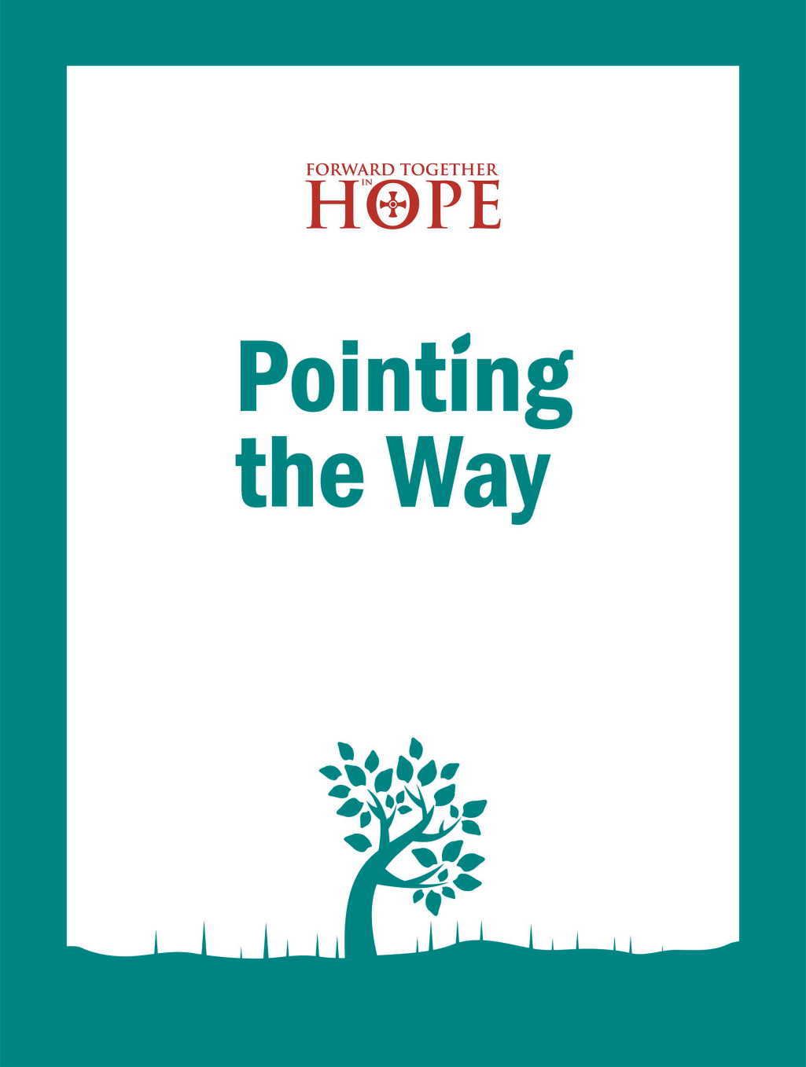

1 Background

*This section explains the overall approach to Forward Together in Hope and how the Exploring the Way stage fits within the journey.*

**1.1 Forward Together in Hope**

*Forward Together in Hope* is our Diocesan journey of renewal. It is about all of us, young or old; lay or ordained; in parishes, schools or housebound working together to explore and discern God’s will for our Diocese. It will not be an easy journey; in the words of Bishop Séamus, *‘This could be painful, but there can be no growth without pain’*.

Between Pentecost and Advent this year, each worshipping community will look in detail at how best it can flourish into the future. Each community will be given information held centrally in the Diocese, and the invitation to every community is to be both painstaking and honest in its approach to a self-evaluation questionnaire.

At the end of the process it is likely that there will be significant change for many of us. Some communities may not be able to worship in their current church but will be able to thrive by joining with a neighbouring community. Other communities may discover a real sense of responsibility in relation to neighbouring communities. A key strength of the approach is that it will take place in the same way across the whole of the Diocese. The entire process will be firmly rooted in prayer and a real openness to the guidance of the Holy Spirit. The success of *Forward Together in Hope* depends on all of us playing our part and thinking beyond the limits of our experience and imagination.

Please get in touch if you have any questions, comments or suggestions.

(0191) 243 3304

hope@diocesehn.org.uk

www.hope.rcdhn.org.uk

**1.2 Stages of the Journey**

****We have described the *Forward Together in Hope* process as three stages on a journey - *Preparing the Way, Exploring the Way* and *Pointing the Way* - and the overall ‘map’ and timescales for the journey are shown in the diagram opposite. Of course, a journey like this can never really end, but we hope that after 3 years we will have discovered some key indicators regarding the future of the Diocese and have started to put the new arrangements in place. Resources will be provided during each stage of the journey to help worshipping communities to reflect prayerfully on the future challenges and opportunities.

**1.3 Exploring the Way**

The aim of this document and the accompanying resources is to help worshipping communities to carry out a careful and prayerful consultation process about their current vitality and future direction. To assist with this we have provided the following items:

* This document - giving an overview of the *Exploring the Way* process and some ideas about how you might approach it.
* The Parish Questionnaire – a three part document that each parish will complete by the beginning of Advent.
* A very brief handout that sets out some key messages about *Exploring the Way* – for distribution to everyone.
* Prayer and liturgy resources to support your community in its reflections.
* A CD containing all of the above items electronically.
* Each lay representative and parish priest will receive a Data Pack on CD and in hardcopy containing information unique to their parish.

The majority of these items are also available on-line from the website shown below.

**1.4 Travelling Together on the Way**

We are committed to communicating as well as we can throughout *Forward Together in Hope*. We want as many people as possible to feel part of this journey and would encourage you to spread this information as widely as you can.

2 Exploring the Way

*This section provides an insight into the Exploring the Way process and offers some ideas for how you might approach it.*

**2.1 Involve, consult and celebrate**

Above all, *Exploring the Way* is about involving and consulting with as many people as possible regarding the present and future of your worshipping community. It is also about identifying and celebrating what your community does well and helping it to focus upon the things that will ensure it can flourish into the future.

We cannot pretend that the process will be simple, straightforward or pain-free. However, if it is approached in a prayerful and inclusive way, there is the potential for it to be a time of real growth, development and strengthening for each community and for the Diocese as a whole.

**2.2 Parish Questionnaire**

By the start of Advent (29th November 2015) each parish in the Diocese is asked to submit a completed Parish Questionnaire. As well as the hardcopy version, the questionnaire is available electronically on the accompanying Resources CD and from [www.hope.rcdhn.org.uk](http://www.hope.rcdhn.org.uk)

The questionnaire has 3 parts:

Part A – *A Picture of Our Community* – provides the opportunity to gather, explore and present facts and figures about a wide range of facets of parish life under each of the 10 key headings we have previously described.

Part B – *Reflective Questions* – key questions under each of the 10 headings for open discussion by your community, along with the opportunity to highlight any other important issues and examples of good practice. We ask that responses to each question in Part B of the questionnaire are a maximum of 250 words.

Part C – *Our Community’s initial thoughts and ideas about the future* – where your parish community is asked to provide its first thoughts about how it might move forward. This is a way of allowing people to imagine what the community will be like in 2030 – just 15 years from now.

**2.3 Data Pack**

Accompanying the questionnaire is a Data Pack containing information unique to your parish and provided only to your parish. This draws from a number of sources held centrally by the Diocese. The reason for providing all of this information, and inviting the community to investigate further facts and figures, is to enable it to have a full and accurate picture of itself. This is essential for future planning. It is hoped that by providing this information, communities are spared some of the work of collating it themselves. The unique Data Pack CD contains the data along with other documents relating to parish property.

Some information will only be available within the parish and you are encouraged to gather and use it as fully as you can when consulting with the community and completing the questionnaire.

**2.4 From Pentecost to Advent**

Over the 6 months between Pentecost and the beginning of Advent the main tasks for each community will be:

* Gathering and exploring a range of data and information to inform the completion of Part A of the questionnaire.
* The involvement of as many people as possible in discussing and contributing to the responses to the Reflective Questions that feature in Part B of the questionnaire.
* A process for collecting and summarising the initial thoughts and ideas that the community has about its future direction for Part C of the questionnaire.

Parishes will approach these tasks in different ways and it is good that they do– as each community knows what is right and possible in its own circumstances. So what follows is not a prescribed approach, but rather some food for thought to help you to plan the best way for you.

We fully appreciate the time and commitment necessary to do this work thoroughly while providing feedback to the community at each stage and listening to their views. We suggest that you plan carefully and use the full 6 months to complete the task.

**3 Managing the Process**

*This section offers suggestions that may be helpful when planning how you will undertake the Exploring the Way process in your community.*

**3.1 Open to the Holy Spirit**

Bishop Séamus has urged us to ensure that *Forward Together in Hope* is firmly rooted in prayer. During the *Exploring the Way* stage of the journey it is important that we invite the Holy Spirit to journey with us, guiding us in our deliberations and inspiring us in our ideas and recommendations for the future. The accompanying prayer and spirituality resources– and those made available previously with the *Preparing the Way* materials– offer a number of suggestions that may be helpful in providing a prayerful context.

**3.2 A Possible Approach**

One possible way of breaking down the process into more manageable ‘chunks’ is as follows:

* 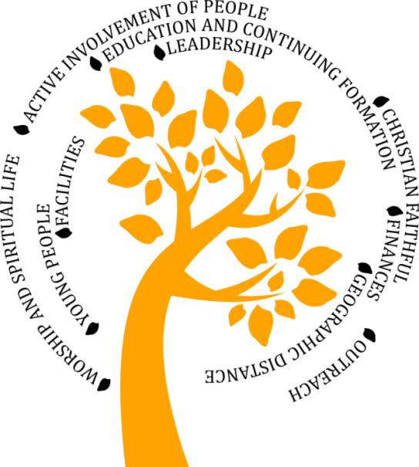Inform everyone about what will be happening over the next 6 months by providing and explaining the brief *Exploring the Way* information sheet to all parishioners at masses or other gatherings shortly after Pentecost. The information sheet (available on the Resources CD and from the website) is produced in black and white for ease of copying and can be customised to include the details of the specific approach you are adopting. This will give people an overview of what will be happening and how they might contribute.
* You may wish to establish a small group to look at the Data Pack and other parish information and to draft the responses to the questions in Part A of the questionnaire. It is worth thinking carefully about who might have the right skills and knowledge to be involved here. It would certainly be important to include school as well as parish representation. This group might also act as the ‘planning group’ for the whole process.
* The group may also turn its attention to developing a summary picture of the information and data about the parish that can be provided to everyone to keep them informed and to provide a background to their thinking about the Reflective Questions. The idea is that those who are able to attend the planned meetings will have advance information about the parish facts and figures. It could be printed and attached to the parish newsletter so that as many people as possible are aware of what is happening. This would respect the invitation to everyone to be involved, including the housebound and others not able to attend the meetings.

* While this preparation work is taking place, parishioners can be informed about the open meetings. They will be able to hear about the findings of the small group and to contribute to the discussion of the Reflective Questions in Part B. The *Exploring the Way* information sheet includes a summary of all of the questions in Part B of the questionnaire so everyone can start to think about these ahead of the meetings. Given the number of questions, it is likely that at least three meetings will be required – although each parish will need to decide the most appropriate approach for them.
* It is important to find ways to ensure that everyone is kept informed about what is emerging from the discussions – and, in particular, informing everyone about the statement about the future direction of the parish community formulated in Part C of the questionnaire.

**3.3 Running the meetings**

We have included a suggested outline (Appendix 1) as a starting point for your thinking. This includes time for prayer, summarising the data and discussing the reflective questions.

In addition, there are some notes (Appendix 2) for those who are willing to take on particular responsibilities in the meetings. We have identified 5 distinct roles here which are fully explained in the appendix. These are:

**

* The Prayer Facilitator
* The Presenter of Data
* The Discussion Facilitator
* The Scribe
* The Chair

If you decide that this approach is a good one for you, it would be worth approaching people ahead of the meetings who have the skills to carry out each of the roles effectively. In some instances a person with the right skills might carry out more than one role.

**3.4 Those who cannot attend meetings**

Direct involvement in the conversations taking place at open meetings is the best way to contribute to the process and should be strongly encouraged. Of course, not everyone will be able to attend the meetings, but the views of everyone in the parish community – including the housebound – are valuable in informing the questionnaire response. Providing the opportunity for everyone to contribute is very important. To assist with this we have summarised the Reflective Questions on the *Exploring the Way* information sheet so that anyone who wishes to can feed in their views verbally or in writing ahead of the relevant meeting. The ideal situation is that these views are included for consideration during the meeting itself and that they are given the same ‘weight’ as verbal comments.

**3.5 Those who rarely attend church**

Any process like this has the danger of only involving those who hear the invitation - just because they happen to be there at the time. It is much more difficult to engage with those who only attend church occasionally – or have a tenuous connection. Yet, if we are serious about the principle of *Forward Together in Hope* being an inclusive process, we need to find ways of communicating the message beyond the doors of the church and seeking a wider range of views.

You may have creative thoughts about how to do this at parish or school level. Our contribution to the task will be to provide, at a later date, an individual questionnaire that will be made available widely through websites and other methods. This will be designed to collect information from people who have something to say but who are not really involved in parish life at present.

**3.6 Involving our schools and young people**

Our Catholic primary and secondary schools have links with the worshipping communities in our parishes – as well as being worshipping communities in their own right. They have direct contact with many families for whom parish worship is rare and they have the opportunity to seek their views about the Church.

It is important that schools are fully represented within the parish consultation and reflection process. In addition, we intend to engage directly with schools and young people later in the year to tap into their views and the views of their families.

**3.7 Bringing it all together**

Having carried out the consultation process and completed Parts A and B of the questionnaire, the community needs to arrive at a statement to include in Part C that presents its initial ideas about the way forward. It is important that this is fully informed by and shared with the whole community.

At the end of this stage of the process, one person will be required to submit the questionnaire responses using an on-line questionnaire tool. This will allow us to collate and analyse responses efficiently. We will be providing information later in the year about how to do this. Rest assured that support will be available to parishes to assist with this.

**Appendix 1: A Possible Meeting Format**

|  |  |  |
| --- | --- | --- |
| **Activity** | **Who** | **Notes** |
| Welcome and Introduction | Chair | * Welcoming everyone * Introducing the Discussion Facilitator, Prayer Facilitator, Data Presenter and Scribe * Setting out the purpose and timing of the meeting * Feeding back information from previous meeting (if appropriate) |
|  |  |  |
| Prayer and Reflection | Prayer Facilitator | * Using prayer and scripture to set the context and atmosphere for the meeting (Possible approaches are available on the *Exploring the Way* Resources CD) |
|  |  |  |
| Presenting the Facts and Figures | Data Presenter | * Briefly outlining the background data and other information in relation to the relevant heading(s) to be discussed. (Using the Data Pack and Questionnaire Part A) |
|  |  |  |
| Discussion of Reflective Questions | Discussion Facilitator | * Introduction of the questions and the task * Depending on the overall group size and the number of questions being covered it may be appropriate to divide the full group into smaller groups (6-8 is probably the optimum size) and invite particular groups to consider particular questions |
|  |  |  |
| Drawing things together | Discussion Facilitator | * Drawing out key points from the groups – possibly using flipchart to log these * Summarising and seeking agreement/challenge from the rest of the meeting |
|  |  |  |
| Consolidating and reflecting | Prayer Facilitator | * Taking the opportunity to reflect prayerfully on what has been discussed – possibly encouraging people to consider where they are personally in relation to this * Concluding with the *Forward Together in Hope* prayer |
|  |  |  |
| Thank you and next steps | Chair | * Thanking people for their contributions * Briefly setting the scene for the next meeting and identifying which questions will be discussed |

**Appendix 2: Roles in the Meetings**

* **The Prayer Facilitator**

The Prayer Facilitator will need to work with the Chair and Discussion Facilitator to ensure that the meetings do not become purely ‘business’ but are truly opportunities for people to share their thoughts and insights in a prayerful and reflective way. You may like to create a focal point to remind people that these meetings have a spiritual dimension and are undertaken under the guidance of the Holy Spirit. It may help to encourage short periods of silence as people read and reflect on the questions before embarking on the discussions.

* **The Presenter of Data**

The Presenter of Data offers a simple but key service, introducing information from Part A (the data gathering part) of the questionnaire. It involves presenting the results under each heading of Part A to the whole group before they begin discussing the same heading for Part B. The aim should be to take *enough* time so that those listening can absorb and understand the data - but not *too much*, since most of the time will be needed for the group’s reflection. Use whatever visual aids seem best to present the information.

* **The Discussion Facilitator**

The role is to facilitate the discussion after the Data Presenter has introduced information from Part A. This will require a good deal of skill and judgement; the aim is to encourage wide participation and to offer a space for genuine reflection together, while maintaining a focus on the questions and helping the group to arrive at an agreed response. If agreement is *not* possible, then it should not be forced; the scribe can instead record the range of views.

It is important to keep an eye on the time, and find a balance between encouraging participation and keeping the conversation focused and moving towards a conclusion. You may need to find ways to prevent some people dominating or distracting the group from the question as well as ways to encourage quieter members to participate. The role will require you to be more focused on managing the discussion than on contributing to it. So you will need the humility to be a facilitator who does not dominate the discussion, but also the confidence not to allow anyone else to dominate it or pull it off course. Your role will be absolutely key.

* **The Scribe**

This is a difficult role; putting into written form, as honestly and accurately as possible, the group’s considered answer to each question. Answers may vary in length, but should not be longer than 250 words. There may not be time to agree an exact wording at the meeting, so you may want to take notes (or a recording) and distil the group’s conclusion into a written response later; this will not necessarily be an easy task.

The aim is to be as faithful as possible to the view that emerges from the group. If it turns out not to be possible for the meeting to reach an agreement, it will be best simply to report the differing views put forward. You should present the written answers in whatever format seems best to you; it is fine to write a single paragraph or more than one, or to use bullet points.

Participants will need to place considerable trust in you to do your best to reflect the ‘mind of the group’. It is important that you present the written answers to all the questions in Part B back to the group before it embarks on Part C.

* **The Chair**

The Chair takes overall responsibility for the meeting, ensuring that it runs to time, and that the others understand their roles. You should introduce the presenters and facilitators and explain the process that will be followed. If necessary, you may need to gently intervene to remind presenters of the time. You will need to have received any verbal or written comments from those not able to attend the meeting and ensure these views are reflected.

At times you may feel it is appropriate to intervene to support the Discussion Facilitator if he or she is struggling to manage voices that are overly dominant. If all is going well and everyone is managing to keep to time, you may have little to do other than to begin and end the meeting. Nevertheless, the function of taking overall responsibility for the progress of the meeting, and supporting others in ensuring that the meeting does not go off-course, is vital.

Acknowledgements

We see *Forward Together in Hope* as a shared responsibility of everyone in our Diocese and are very grateful to the many people who have contributed in various ways to the development of the materials in this resource pack.

In particular, we would like to thank:

* The dioceses that have carried out similar reviews and from whom we have ‘borrowed’ some good ideas. The work of the Diocese of Belleville in Illinois has been especially helpful.
* Xavier Javier for his creative designs.
* Kathryn Turner and Karen Brown who developed the prayer and liturgy resources.
* Paul Nugent for his painstaking work on data collection and analysis.
* Professor Karen Kilby and Dr Mathew Guest, Centre for Catholic Studies, University of Durham, who provided advice about the construction of the parish questionnaire and other support.
* Members of the focus group that provided feedback on the draft questionnaire, namely, Terri Leach, Peter Brookes, Revs Chris Hughes, Michael McCoy, Dennis Tindall and Rob Wareing.
* Members of the Diocesan Development Group who oversee the work of *Forward Together in Hope*, namely, Fr Martin Stempczyk, Bill Dryden, Kathleen Smith and Kathryn Turner.
* The clergy and lay representatives who have been so co-operative in attending and contributing to meetings and communicating information to those in worshipping communities.

Finally, very many thanks to my many colleagues in various Curial Departments, some of whom have spent many hours of their own time putting data and information into a useable form. While we have done our best to ensure that all information included in this resource pack is accurate, I apologise in advance and take responsibility for any omissions or inaccuracies you might discover.

**Jim O’Keefe**

Diocesan Development Director

The *Forward Together in Hope* team: Jim O’Keefe, Tony Sacco and Nancy Gash can be contacted on:

Telephone: (0191) 243 3304 E-mail: hope@diocesehn.org.uk

Diocese of Hexham and Newcastle, Department for Development and Renewal

Tel: (0191) 243 3304 E-mail: hope@diocesehn.org.uk Web: www.hope.rcdhn.org.uk

©Diocese of Hexham and Newcastle – May 2015

Also available in other formats

